**NOVAX - STARTUP PITCHING PLATFORM**

**A Project Report**

***Submitted by:***

**SWAPNIL BATTACHARYA (24030142023)**

***in partial fulfilment for the award of the degree***

***of***

**M.SC. COMPUTER APPLICATION**

**IN**

**COMPUTER STUDIES**

at

**SYMBIOSIS INSTITUTE OF COMPUTER STUDIES AND RESEARCH, PUNE, INDIA**

**AFFILIATED TO SYMBIOSIS INTERNATIONAL (DEEMED UNIVERSITY) (INDIA)**

**MONTH & YEAR**

## **DECLARATION**

I hereby declare that the project entitled “**NovaX Startup Pitching Platform**” submitted for the M.Sc. Computer Application degree is my original work and the project has not formed the basis for the award of any other degree, diploma, fellowship or any other similar titles.

**Signature of the Students**

**Place: Pune**

**Date: 25/03/2025**

## **CERTIFICATE**

This is to certify that the project titled “**NovaX Startup Pitching Platform**” is the bona fide work carried out by **SWAPNIL BHATTACAHRYA**, a student of M.Sc. Computer Application of Symbiosis Institute of Computer Studies and Research, Pune India, affiliated to Symbiosis International (Deemed University) during the academic year 2024-25, in partial fulfilment of the requirements for the award of the degree of M.Sc. Computer Application.

Dr. Amol Vibhute

**Signature of the Guide**

**Place: Pune**

**Date: 25/03/2025**

## 

## **Acknowledgment**

## We would like to thank Dr. Amol Vibhute, our project mentor, for all his counsel, direction and unstinted support. I would like to extend my sincere gratitude to our peers who guided me throughout this project and for their constructive criticism.

## 

## **Abstract**

NovaX is a new Startup Pitching Platform aiming to connect transform the relationship between entrepreneurs and investors by placing technology front and centre of the process. Built using Next. 15 and React19, with Sanity handling the content management. Volare is a convergence of the existing tech and user-centric design to create a golden experience for entrepreneurs and investors alike.

The main feature of course is a live homepage showing all the submitted startups in real-time, so users are presented with the latest ideas. It is very easy for Entrepreneurs to submit their startups through a simple startup creation form, which requests vital information like title, description, category and optional media like images or videos. Every startup also has a separate page, with a views counter that tracks and shows how many times the pitch has been viewed, providing an open metric for engagement.

Allowing users to quickly log in, NovaX uses NextAuth with GitHub Authentication for a seamless experience. When they authenticate, users can access their profile page where they can view their posted startups. They are also an open portfolio, from which other people can see startups posted by a specific author.

NovaX boosts discoverability with a robust search feature, where users can search startups by name, category, or author. This feature allows users and investors to easily reach the appropriate ideas or creators. The platform uses Sanity as its backend for real-time content updates and efficient data management. Monitoring errors and tracking (to provide a stable and seamless experience for users) is also done using Sentry. NovaX is all about minimalism and clean UI using TailwindCSS. Its streamlined design enables the users to navigate the platform with ease, focusing on what matters the most—discovery and the presentation of new ideas.

NovaX is more than just a platform; it’s a community-driven innovation ecosystem. For entrepreneurs who want to pitch their next great idea or investors searching for innovative startups. NovaX gives a solution with tools and infrastructure that creates an efficient and effective process. As always feedback and participation is welcome as the platform grows and matures with each version.

## **Table of Content**

**1. INTRODUCTION** 6

1.1 PROBLEM DEFINATION 7

1.2 LITERATURE SURVEY 8

A. Startup Pitching Platforms and Their Evolution 8

B. Investor Engagement in Digital Ecosystems 8

C. User-Centric Design in Modern Web Applications 8

1.3 BACKGROUND 9

1.4 REASEARCH OBJECTIVES 10

1.5 SIGNIFICANCE OF THE STUDY 11

1.6 METHODOLOGY 13

1.7 HARDWARE AND SOFTWARE REQUIREMENTS 14

1.8 SCOPE AND LIMITATIONS 15

**2. SYSTEM DESIGN AND ANALYSIS** 16

2.1 SYSTEM OVERVIEW 16

2.2 SYSTEM REQUIREMENTS 17

2.3 SYSTEM ARCHITECTURE 19

2.4 SYSTEM DESIGN 21

2.5 SECURITY AND PERFORMANCE CONSIDERATIONS 23

2.6 SYSTEM TESTING 25

2.7 ALGORITHM IMPLEMENTATION 28

2.8 COMPARATIVE ANALYSIS 31

2.9 CHALLENGES 32

**3. CONCLUSION** 33

**4. REFERENCES** 35

**5. APPENDICES** 36

## 

## **1. INTRODUCTION**

If you think about it, you can imagine one big obstacle, Entrepreneur meet Investor or not Then there is the entrepreneur, bursting with original ideas, but lacking an integrated platform in which to place them. Now imagine the investor starving for these original startups, but unable to find them. Cue NovaX, the Next-Generation Startup Pitching Platform. It’s here to fill this chasm, to create an unending ecosystem fertile for innovation. How, you ask? By harnessing the raw power of Next.js 15, React 19, and the sheer might of Sanity content management. A beacon in the night, NovaX provides durable, accessible, and user-centric pitching strategies. See those startup ideas? NovaX manages them all, making the challenging seem effortless.

How, you ask? Utilizing the raw power that Next.js 15, React19, and the raw power of Sanity content management. However, NovaX shines as a guide in the dark, offering quick, practical, and equitable pitching approaches. See those startup ideas? NovaX orchestrates them all, the difficult appearing effortless. A live overview of submitted startups to NovaX the page that is the heart of NovaX beating. Submitting startup pitches? With NovaX, creating a startup is a piece of cake for entrepreneur’s form. Indispensable aspects such as title, description, category? Captured effortlessly. Wanna throw in a little verve in there? Add multimedia content. Views, counts, live updates? On direct page of each of the startup. Fun, transparent, metric-fulfilling. Security: Paramount. Accessibility: Seamless. Solution: GitHub Authentication using NextAuth The result? Effortlessly logging in. Having authenticated, users’ startup creations are all available for inspection on their profile page. However, it is not just a straight-up display. This profile? It’s your public portfolio, which invites others to check out your genius. Discovered NovaX yet? Highly refined search tools help. Find startups by title, category, author: the choice is yours.

Empowered by the indomitable power of Sanity as its backend, NovaX guarantees real-time content updates coupled with elegant data management. Sum it up in a sentence? Seamless and dependable user experience, with Sentry error tracking and monitoring integrated. With its sleek, contemporary design, NovaX is a House of Innovation which continues to thrive. TailwindCSS ensured optimal usability in the design of its foundation. The NovaX revolution has arrived. Users can easily navigate the platform thanks to its simplified design, concentrating on what really matters—new ideas and discovery.

NovaX is a community-driven innovation ecosystem rather than merely a platform. NovaX offers the infrastructure and tools necessary to create a smooth and successful process, whether you're an investor seeking out creative startups or an entrepreneur hoping to pitch your next big idea. As the platform develops and changes with each iteration, participation and feedback are always appreciated.

## **1.1 PROBLEM DEFINATION**

The startup ecosystem makes it easier for entrepreneurs to work together and exchange potential ideas. However, there are a lot of obstacles in the world that prevent investors and entrepreneurs from connecting.

Investors lack a central venue to showcase their innovative ideas as they scramble to identify and assess the next big thing.

**Few Key Issues are:**

1. ***Fragmented Platforms:*** Entrepreneurs and investors stuck handling an array of disparate platforms, leading to inefficiencies and chances slipping through the gaps.
2. ***Limited Discoverability:*** Investors struggle to spot startups that mirror their interests due to poor search and filtering capabilities.
3. ***Lack of Engagement Metrics:*** Opacity of engagement metrics. Entrepreneurs have no clear way to measure the visibility or engagement with their pitches.
4. ***Inefficient Onboarding:*** Traditional authentication systems are often burdensome and discourages users from joining or interacting with the platform in the first place
5. ***Lack of Real-Time Features:*** Platforms stuck in the past, failing to offer dynamic, live updates and hence dampening user engagement and interests

Introducing NovaX, a state-of-the-art, scalable, user-focused platform created to close the gap between entrepreneurs and investors. Naturally, adding real-time updates enhances search capabilities and fortifies its security with secure authentication.

NovaX makes startup discovery and pitching easier by getting rid of the inconvenient and ineffective. The ecosystem requires a revolution to become efficient and seamless.

## **1.2 LITERATURE SURVEY**

### **A. Startup Pitching Platforms and Their Evolution**

### The days of traditional in-person pitch events are long gone. Over the past ten years, startup pitching platforms have undergone a substantial transformation and a slow transition into the digital sphere. Entrepreneurs could post their ideas and investors could review them on early platforms that emphasized simple listing features. Real-time updates, interaction, and sophisticated search features were absent from some of these platforms.

### With ever-more-advanced features, contemporary platforms such as Gust and AngelList entered the market. Multimedia integration, investor matching, and analytics. Nonetheless, there is still a need for platforms that emphasize real-time communication, are user-friendly, and can accurately identify still echoes.

### **B. Investor Engagement in Digital Ecosystems**

### Engaging investors turns out to be a critical component of success. Research indicates that investors are drawn to platforms that offer them the gifts of tailored suggestions, clear metrics, and effective search algorithms. In an effort to increase engagement, companies like Crunchbase and SeedInvest have outfitted themselves with investor dashboards, data analytics, and excellent filtering options. That is essential to maintaining the interest of the investment community.

### **C. User-Centric Design in Modern Web Applications**

At the heart of today's web applications resides user-centric design, a practice that boasts of crafting interfaces that are straightforward, accessible, and stimulating. Platforms like LinkedIn and Medium have forged the path, for user experience by prioritizing clean layouts, fluid navigation, and tailored content are a testament to prioritizing the user.

A key component of startup pitching platforms is the design sentiment. Both entrepreneurs and investors will find the platform easy to use. They easily keep an eye on all activities, exchange ideas, submit them, and locate others.

NovaX uses TailwindCSS and React to create an intuitive, responsive, and visually appealing interface that ensures a faultless user experience.

## 

## **1.3 BACKGROUND**

A thriving centre of innovation, the global startup ecosystem propels economic expansion and advances technology. At the forefront are entrepreneurs who are dissecting innovative ideas to address pressing issues. However, the process from conception to execution typically depends on financial resources and investor support. This used to rely largely on antiquated techniques, such as pitching competitions, networking events, and personal connections. However, these were frequently constrained by time constraints, scalability problems, and geographic constraints.

The way that investors and startups interact is changing because of the digital revolution. This is made possible by online platforms that allow for interactions that transcend geographical limitations. The forerunners? mainly offered basic services like contact information disclosure and startup listings. addressed some of the inefficiencies, but not enough of the interactive features, which drive true engagement. Starting in 2016, platforms like Crunchbase and AngelList introduced premium offerings (e.g. investor dashboards, analytics, and multimedia support). The glitch? Many of these still fall short in the provision of personalized experiences and real-time updates, as well as in the provision of smooth user interactions.

Modern web development frameworks like React and Next. js. These were technological wonders which revolutionized the way web applications were developed. enhanced developers’ capacity to build rapid, flexible platforms with rich user interfaces. Content management systems like Sanity provided real-time data synchronization as well, allowing for very easy management and projecting of dynamic content.Tools like Sentry, which ensure platform dependability through real-time error tracking and monitoring, enhance the user experience in addition to this.

As a result of this technological advancement, NovaX was created to fill in the gaps in the startup pitching platforms that are currently in use. NovaX presents itself as a cutting-edge, scalable, and user-friendly solution for business owners by combining cutting-edge technologies with a dedication to user-focused design. Making their ideas more visible, enabling investors to unearth groundbreaking startups. It's a platform sculpted to foster a more cohesive, effective, and immersive ecosystem.

## 

## **1.4 REASEARCH OBJECTIVES**

NovaX's construction process is steered by firm, rigorous research goals. They tackle the tribulations faced by the daring entrepreneurs and informed investors in the cutthroat startup ecosystem. Objectives, meticulously designed to yield a platform that smoothly merges functionality with impact, user-friendliness, and scalability.

Here, our foremost research objectives are spotlighted:

1. ***To birth a Centralized Startup Pitching Platform:*** A cohesive platform, entrepreneurs showcasing their groundbreaking ideas, investors finding the next big thing. No more divided, disjointed solutions.
2. ***To Support Discoverability:*** Advanced search, superior filtering empowers users to unearth startups by title, category, author. Efficient, targeted discovery awaits.
3. ***To Deliver Real-Time Updates, Engagement Metrics***: Integration of live content updates, view counter for tracking sparkling engagement metrics. Transparency and insights, a precious gift for all entrepreneurs and investors.
4. ***To Offer Secure, Seamless User Experience:*** GitHub Authentication through NextAuth, the key to hassle-free, secure user onboarding. Safety is an investment.
5. ***To Craft User-Centric Interface:*** TailwindCSS and React shape up a modern, minimalist, intuitive user interface. Easy navigation, visually captivating experience form the heart of our platform.
6. ***To Utilize Scalable, Efficient Backend Solutions:*** Real-time content management, data synchronization powered by Sanity. The platform, robust enough to manage dynamic content, scalable at the same time.
7. ***To Supervise, Upgrade Platform Reliability:*** Sentry for error tracking, consistent monitoring. A stable and reliable user experience inevitable, continuous improvement, a promise we'd fulfil.
8. ***To Nurture a Community-Driven Ecosystem:*** A platform that thrives on collaboration, feedback, participation. Continuous evolution, adaption to user needs, the cornerstones of our mission.

By achieving these objectives, NovaX aims to revolutionize the way startups are pitched and discovered, creating a more connected, efficient, and engaging ecosystem for entrepreneurs and investors alike.

## **1.5 SIGNIFICANCE OF THE STUDY**

The development of NovaX has a significant impact on the varied participants in the startup ecosystem, including astute investors, enterprising entrepreneurs, and the larger creative community.

The following significant advantages are promised by the research and implementation of such a platform, which aims to address important issues:

1. ***Entrepreneurs and their Empowerment:*** NovaX provides entrepreneurs with a fundamentally cohesive platform to present their innovative concepts. It opens the door to a wider range of potential investors. Tools that provide multimedia backup, engagement metrics, and real-time updates transform the platform into a catalyst that aids entrepreneurs in successfully showcasing their startups and keeping a consistent progress log*.*
2. ***Investors and the Startup Road:*** Finding and assessing startups that fit the bill can be a tricky business for many (if not all) investors. Now for NovaX. Its advanced search and filtering as well as similar functionality helps the Investors easily to search and connect such startups who are doing really well.
3. ***Transparency and Engagement:*** Tools like view counters and platform-integratable realtime updates offer insights into startup perception and engagement.Transparency is a win-win win — for investors who can make smarter decisions, for the entrepreneurs who can measure how their pitches are received.
4. **User-Centric Graphics:** By betting on a modern, clean and easy-to-use interface NovaX ensures that users at the platform have a seamless experience. This is mainly because of its first emphasis on user experience, which makes the platform more enjoyable to use and leads to greater participation.
5. **Beyond the Edge of the Cutting Edge**—Integrating Next. js, React, Sanity & Sentry Reflect The Leverage Of Modern Web Development
6. **User-Centric UX Design**: NovaX provides a seamless experience for all users on the platform, betting on a modern, minimalist, and easy-to-use platform. With a seamless user experience at its core, the platform is fun to use, and this promotes higher engagement.
7. **Technologies Like Next** — At the Edge of Leading Tech js, React, Sanity and Sentry highlights the power of contemporary internet development instruments to deal with actual world issues.
8. **Creating a Community-Oriented Space**: NovaX is not just a tool. It’s a community-governed environment that fosters collaboration, relies on feedback, drives progress. For this reason the platform allows everyone to develop and learn in groups.
9. **Innovate, Generate:** NovaX fosters entrepreneurs and investors to help facilitate growth for their next innovations and startups that grow the economy. This inevitability is responsible for both technological and economic progress.

## **1.6 METHODOLOGY**

To be strong, intuitive, and in accordance with the preferences of its audience, NovaX's constantly changing framework adopts a methodical, iterative shape. The following crucial stages comprise the methodology:

**a. Identification and Motivation of Problems:**

- Through close inspection, hidden difficulties that the startup scene's investors and entrepreneurs faced became apparent.

- The shortcomings of the current platforms were noted, including inadequate traceability, a lack of real-time updates, and inefficient user integration.

- To address this, a clear goal and platform scope were established, which effectively addresses these problems.

**b.** **Platform Design and Development:**

- TailwindCSS and React came together to create a user-targeted interface that prioritized a clean, contemporary aesthetic and an intuitive user experience.

- Smooth navigation and fast server-side rendering are made possible by Next.js 15, which is essential for platform frontend development.

- Sanity makes it simple for the backend to manage content in real time and synchronize data.

- A submission form designed specifically for startups enables business owners to confidently present their concepts, adorned with relevant information.

- Users can manage and showcase their published ventures on a profile page.

**c.** **Combining Authentication with Real-Time Features**

- The incorporation of authentication and real-time features. We can incorporate real-time updates thanks to Sanity's Content API. As a result, the homepage can display the most recent startup pitches without any lag.

- By recording how often each startup pitch is viewed, a views counter provides an analytical advantage.

- Enabled advanced search functionality for users should they choose to seek startups by title, category, or author.

**d. User Experience Testing and Evaluation:**

- Thorough functional testing was necessary to make sure all features, including startup submission, search, and authentication, operated as intended.

- We were able to guarantee a seamless, intuitive user experience by using usability testing to collect input on the platform's layout and navigation.

- Platform to performance testing to cut down on load times and boost responsiveness, key for real-time updates and dynamic content.

- Performance testing of the platform to reduce load times and improve responsiveness is essential for dynamic content and real-time updates.

**e. Application deployment:**

- Deployed the application on Vercel, a modern cloud platform optimized for Next.js applications, ensuring fast performance and scalability.

- After deployment, I monitored the platform using Sentry and Vercel Analytics to track performance, identify errors, and gather user data to inform future iterations.

## **1.7 HARDWARE AND SOFTWARE REQUIREMENTS**

### **Hardware Requirements**

|  |  |  |
| --- | --- | --- |
| **Component** | **Minimum Specification** | **Recommended Specification** |
| Processor | 2-core CPU (Intel i5 or equivalent) | 4-core CPU  (Intel i7 or equivalent) |
| RAM | 8GB | 16GB or higher |
| Storage | 20GB free disk space | 50GB free disk space  (SSD recommended) |
| Internet Connection | Stable high-speed internet  (10 Mbps) | High-speed internet  (50 Mbps or higher) |
| Server (Vercel) | 2-core CPU, 2GB RAM | 4-core CPU, 4GB RAM |
| Client Device | Modern browser  (Chrome, Firefox, Edge) | Modern browser with latest updates |
| Client Display | 1280 x 720  resolution | 1920x1080  resolution or higher |

### **Software Requirements**

|  |  |  |
| --- | --- | --- |
| **Category** | **Minimum Specification** | **Recommended Specification** |
| Frontend Development | Next.js 15, React 19, TailwindCSS, TypeScript | Latest versions of Next.js, React, TailwindCSS |
| Backend Development | Sanity, NextAuth | Latest versions of Sanity, NextAuth |
| Version Control | Git | Git with GitHub/GitLab integration |
| Runtime Environment | Node.js 16.x | Latest LTS version of Node.js |
| Testing Tools | Jest, Cypress | Latest versions of Jest, Cypress |
| Error Tracking | Sentry | Latest version of Sentry |
| Deployment & Hosting | Vercel, Sanity | Latest versions of Vercel, Sanity |

### **Development Environment**

* **Code Editor**: WebStorm
* **CI/CD Pipelines**: GitHub Actions
* **Security and Monitoring**: Sentry
* **Content Management System:** Sanity
* **Deployment Platform:** Vercel

## **1.8 SCOPE AND LIMITATIONS**

NovaX connects two worlds that rarely meet entrepreneurs and investors = the matchmaker you never knew you needed. Harnessing the ability of modern technology, it offers a space dedicated to both curious exploration and well-groomed startup presentations.

It is as if it were an open canvas, and it allows innovators to lay out their ideas through a title, a description, a few category tags and perhaps some multimedia content. In turn, venture capitalists can utilise advanced search and filtering tools that aid them in scouting, sorting, and sifting through the world of startups. With real-time updates ensuring the newest pitches are always visible, the platform prides itself on its dynamic nature, as well as its legendary transparency.

There is, however, some conditions with NovaX. It relies on external services such as GitHub and Sanity, so it's subject to changes or outages on their part. Since this is presently a web-only platform, there are no native mobile apps, which could potentially limit the mobile experience. Nor does it include sophisticated features such as analytics or investor dashboards.Timing, tone, and effective outreach and marketing strategies are key for user adoption.

## **2. SYSTEM DESIGN AND ANALYSIS**

### **2.1 SYSTEM OVERVIEW**

NovaX isn't just another platform for startups. It's an online platform that serves as a meeting place for business owners and possible investors. It all comes down to intuitive interactions and natural connections, which are skillfully made possible by a smooth interface. Modern web technologies, specifically Next.js 15, React 19, and TailwindCSS, are the foundation of NovaX.

The outcome? An incredibly quick, responsive, and aesthetically pleasing user experience enables business owners to submit their startup concepts, along with optional multimedia content like pictures or videos and other details like a title, description, and category. Users can easily find the newest ideas thanks to the homepage's real-time display of these pitches.

**NextAuth** powered **GitHub authentication** offers a safe and convenient login process. Users access their profile page after passing through the gates. a private area where they can see and oversee each startup they've founded. The individual startup page comes next. An audience counter to monitor and show metrics related to engagement.

Users can search for startups by author, category, or title using an advanced search feature. **Sanity**, a powerful content management system that guarantees real-time updates and effective data synchronization, powers the backend. **Sentry** helps with error tracking and monitoring to keep the platform error prone.

**Vercel** hosts NovaX, a lightweight platform that makes use of its auto-scaling features and Next.js application performance optimization.

### **2.2 SYSTEM REQUIREMENTS**

### **2.2.1 Functional Requirements**

1. **User Authentication:**
   * Users must be able to log in securely using **GitHub Authentication** via **NextAuth**.
2. **Startup Submission:**
   * Entrepreneurs should be able to submit their startup ideas through a form, including fields for **title**, **description**, **category**, and optional **multimedia content** (images or videos).
3. **Dynamic Content Updates:**
   * Homepage displays all the startups already posted **(new posts must be visible within 60 seconds due to CDN caching)**
4. **Startup Details Page:**
   * Each startup must have a dedicated page displaying its **title**, **description**, **category**, **multimedia content**, and **views counter**.
5. **Profile Management:**
   * They should be able to go to a profile page where they can see and manage all the startups they’ve published.
6. **Search Functionality:**
   * This will only include an advanced search bar that allows users to search for startups by title, category, or author.
7. **Error Tracking and Monitoring:**
   * Sentry integration for real-time error tracking and monitoring for a reliable platform.
8. **Responsive Design:**
   * The platform must be fully responsive, providing an optimal user experience across **desktops**, **tablets**, and **mobile devices**.

### **2.2.2 Non-Functional Requirements**

1. **Performance:**
   * The platform must load within **2-3 seconds** on average, even with dynamic content and CDN caching.
2. **Scalability:**
   * The platform must handle **high traffic** and a growing number of users and startups without performance degradation.
3. **Security:**
   * User data and authentication must be secure, with encryption for sensitive information and protection against common web vulnerabilities.
4. **Reliability:**
   * The platform must have an **uptime of 99.9%**, with minimal downtime or disruptions.
5. **Usability:**
   * The platform must feature an **intuitive and user-friendly interface**, ensuring ease of navigation for all users.
6. **Compatibility:**
   * The platform must be compatible with **modern web browsers** (Chrome, Firefox, Edge, Safari) and **devices** (desktops, tablets, mobiles).
7. **Maintainability:**
   * The codebase must be well-documented and modular, allowing for easy updates and future enhancements.
8. **Deployment:**
   * The platform must be deployed on Vercel, leveraging its auto-scaling, CDN caching, and performance optimization features.

### 

### **2.3 SYSTEM ARCHITECTURE**

NovaX follows a **three-tier architecture:**

### **2.3.1 Presentation Layer (Frontend)**

***Technologies: -***

**- Next.js 15:** involved in server-side rendering (SSR), the creation of a static site (SSG), and the navigation of it all, the routing.

**- React 19:** It's tasked with designing and developing interactive UI components that can be used again and again.

**- TailwindCSS:** It designs a modern, responsive, visually simple, but effective user interface.

**- TypeScript:** Used for developing code that is both safe in terms of type and scalable.

***Key Components: -***

- **Homepage:** All submitted startups are displayed here with dynamics updates refreshed every 60 seconds due to CDN caching.

- **Startup Creation Form:** Place where entrepreneurs can publicly share their startup ideas with necessary details like title, description, category, and multimedia content.

- **Startup Details Page:** The info hub for each startup, topped with a views counter.

- **Profile Page:** Where users can view and manage their published startups.

- **Search Bar:** Useful when you need to find startups by title, category, or author.

### **2.3.2 Application Layer (Backend & Logic)**

***Technologies: -***

* **Next. js API Routes:** A feature of nextjs that enables us to handle server-side logic and serve API requests.
* **Requires 1:** NextAuth- Used for GitHub Authentication and for user authentication and session management.
* **Sanity Client**: Help fetching and updating data interacting with the Sanity backend

***Key Components: -***

* **Authentication:** It handles the user and session login information through GitHub Authentication.
* **Startup Submission Logic** The process of validating and processing the data from the Startup Creation Form gets done easily
* **Real-Time Updates** — A component that checks every 60 seconds if you have new startup data fetched from Sanity that should be displayed on the frontend.
* **Handling Errors**: Enabled by adding Sentry for real-time error tracking.

### **2.3.3 Data Layer (Database & Cloud Storage)**

***Technologies: -***

* **Sanity:** Real-time headless CMS, database and synchronization solution.
* **Vercel Edge Network:** CDN caching and fast content delivery.

**Key Components: -**

* **Startup Data:** Title, description, category, multimedia data, and view count.
* **User Data:** For managing user profiles, authentication data — where their startups are published.
* **Multimedia Storage:** This is the place where images and videos uploaded by users for their startup pitches reside.
* **CDN Caching:** Ensures timely content delivery by caching data on Vercel’s edge network, with updates reflected every 60 seconds.

### 

### **2.4 SYSTEM DESIGN**

### **2.4.1 Use Case**

### **2.4.2 Data Flow Diagrams (DFD)**

*DFD Level 0 (Context Diagram)*

*DFD Level 1 (High Level Diagram)*

*ER Diagram*

### 

### **2.5 SECURITY AND PERFORMANCE CONSIDERATIONS**

### **Security Considerations**

1. *Authentication and Authorization:*

* GitHub pulls its weight through NextAuth, securing user login and keeping sessions in check. Simple, right?
* Role-Based Access Control (RBAC) steps in, throws a safety net around sensitive operation access. Only authenticated users have the keys to this kingdom.

2. *Data Encryption:*

* HTTPS: The secret whisperer between the client and server. Subtle, understated encryption prevents data from being intercepted.
* You can trust us with your secrets. User credentials, sensitive data, they're encrypted before being tucked away into storage.

3. *Input Validation and Sanitizations:*

* We've got your back against injection attacks. All user inputs, from startup details to search queries, they're validated and sanitized. Like a hygiene routine for data.

4. *Error Handling and Monitoring:*

* *Sentry: Monitors happenings, logs errors. Quick on the draw to identify and dismantle security vulnerabilities.*

*5. Content Security Policy:*

* *CSP headers stand tall against cross-site scripting (XSS) and other code injection assaults. Pre-emptive protection, that's what we're about.*

*6. Rate Limiting:*

* *Limits the number of requests from a single IP address to prevent brute-force attacks and abuse.*

### **Performance Considerations**

1. *Efficient Data Fetching:*

* Sanity’s Content Delivery Network (CDN) is our pit stop. Caches startup data, helps us go the extra mile with speed and performance.
* Incremental Static Regeneration (ISR) by Next.js is a breath of fresh air. Updates homepage and startup details pages without a full rebuild. Efficiency at its finest.

2. *Optimized Frontend:*

* TailwindCSS brings style and substance to the table. Light as a feather design keeps render times low. Easy on the eyes and servers.
* Lazy Loading; It's not procrastination, it's strategy. Images and multimedia content stroll in when needed, cutting down on initial page load times.

3. *Scalable Backend:*

* Sanity Backend is a real-time data synchronization maestro. Ready for our growing treasure trove of startup data, never missing a beat.
* Vercel Deployment: It's like having a personal trainer for the system. Auto-scaling capabilities handle high traffic, ensure consistency even when the going gets tough.

4. *Caching Strategies:*

* CDN Caching: Startup data makes a pit stop on Vercel’s edge network. It's like a pit crew in a race. Quick and efficient with updates every 60 seconds.
* Browser Caching: We use the memory powers of your browser. Static assets are cached, reducing repeated load times. Saving time and nerves.

5. *Error Tracking and Optimization:*

* Sentry sets the pace. Monitoring performance bottlenecks and errors and shaping up the platform through continuous optimization.

6. *Database Optimization:*

* Indexing is our lifeboat, making data retrieval a breeze, conquering the high seas of database queries.
* Our queries, lean and mean, fetch only the data needed. Easy on the backend load.

### 

### **2.6 SYSTEM TESTING**

Ensures that NovaX meets the functional and non-functional requirements. These tests focus on usability, performance, security and functionality across different devices

### **2.6.1 Testing Approach**

- *Black Box Testing:* zeroes in on the functionality, examining the nuts and bolts of a system without bothering with the complexities of the internal code.

- *White Box Testing:* Examines the internal structure and logic of the code to ensure it works as intended.

**-** *Manual Testing:*Performed to validate user experience and edge cases.

### **Testing Levels:**

- *Unit Testing:* Tests individual components (e.g., startup creation form, search functionality).

- *Integration Testing:* Ensures that different modules (e.g., frontend, backend, database) work together seamlessly.

- *System Testing:* Validates the system against functional and non-functional requirements.

- *User Acceptance Testing (UAT):* Conducted with real users to ensure the platform meets their needs.

### **2.6.2 Test Cases and Steps**

|  |  |  |  |
| --- | --- | --- | --- |
| **Test Type** | **Test Case** | **Steps** | **Expected Result** |
| **Functional Testing** | Verify startup submission functionality. | 1. Log in as a user. 2. Fill out the startup creation form. 3. Submit the form. | Startup is successfully created and displayed on the homepage. |
|  | Verify search functionality. | 1. Enter a search query (e.g., title, category). 2. Click "Search." | Relevant startups are displayed in the search results. |
|  | Verify GitHub Authentication. | 1. Click "Login with GitHub." 2. Complete the GitHub OAuth flow. | User is authenticated and redirected to the homepage. |
| **Usability Testing** | Evaluate ease of navigation. | 1. Navigate through the platform (e.g., homepage, profile page, startup details). | Users can easily navigate the platform without confusion. |
|  | Test responsiveness on different devices. | 1. Access the platform on desktop, tablet, and mobile. | Platform is fully responsive and functional on all devices. |
| **Performance Testing** | Measure page load times. | 1. Load the homepage and startup details page. 2. Record load times. | Pages load within 2-3 seconds. |
|  | Test platform under high traffic. | 1. Simulate high traffic using tools like JMeter. | Platform remains stable and responsive under load. |
| **Security Testing** | Test for SQL injection vulnerabilities. | 1. Enter malicious SQL queries in input fields. | Inputs are sanitized, and no vulnerabilities are exploited. |
|  | Verify HTTPS encryption. | 1. Check if the platform uses HTTPS. | All communication is encrypted using HTTPS. |
| **Compatibility Testing** | Test platform on different browsers. | 1. Access the platform on Chrome, Firefox, Edge, and Safari. | Platform functions correctly on all supported browsers. |

### **2.6.3 Future Testing Enhancements**

1. **Automated Regression Testing:**
   * Implement automated regression tests to ensure new updates do not break existing functionality.
2. **Load Testing:**
   * Conduct more extensive load testing to evaluate platform performance under extreme traffic conditions.
3. **Accessibility Testing:**
   * Ensure the platform meets accessibility standards (e.g., WCAG) to support users with disabilities.
4. **Localization Testing:**
   * Test the platform with different languages and regional settings to ensure global compatibility.
5. **Penetration Testing:**
   * Perform penetration testing to identify and address potential security vulnerabilities.

### 

### **2.7 ALGORITHM IMPLEMENTATION**

### **1. Startup Submission and Validation Algorithm**

**Purpose:** Validates and processes startup data submitted by users.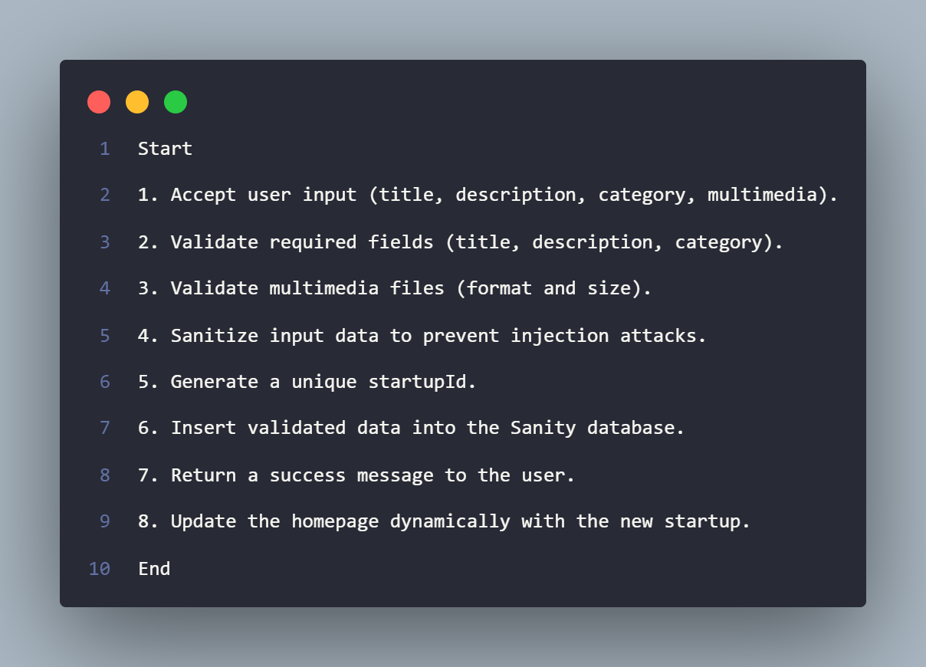

### **2. Search Algorithm**

**Purpose:** Enables users to search for startups by title, category, or author.



**3. Views Counter Algorithm**

**Purpose:** Tracks and updates the number of views for each startup.

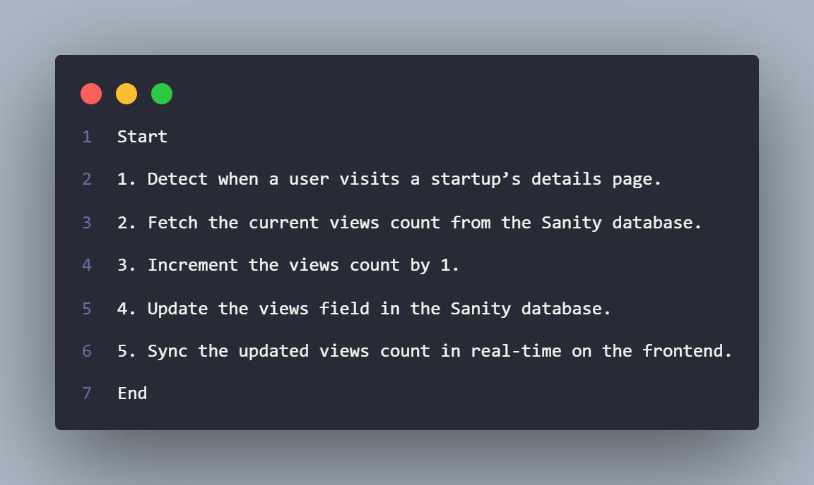

### **4. Error Tracking Algorithm**

**Purpose:** Monitors and logs errors for debugging and performance optimization.

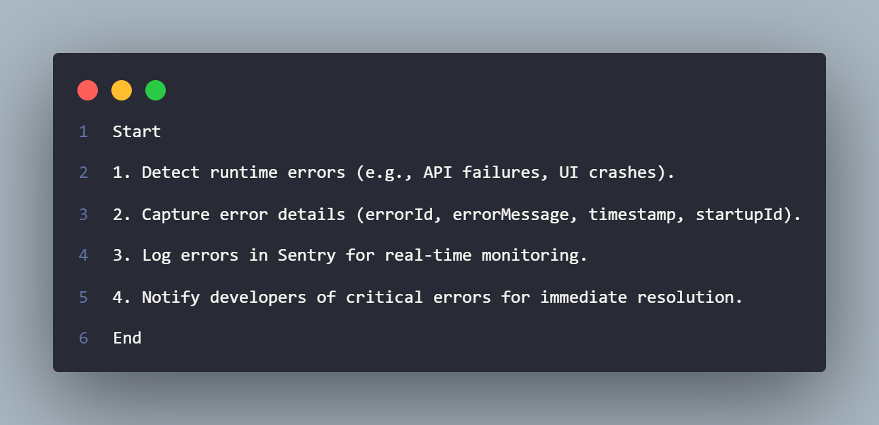

### **5. Authentication Algorithm**

**Purpose:** Manages user login and session management securely.

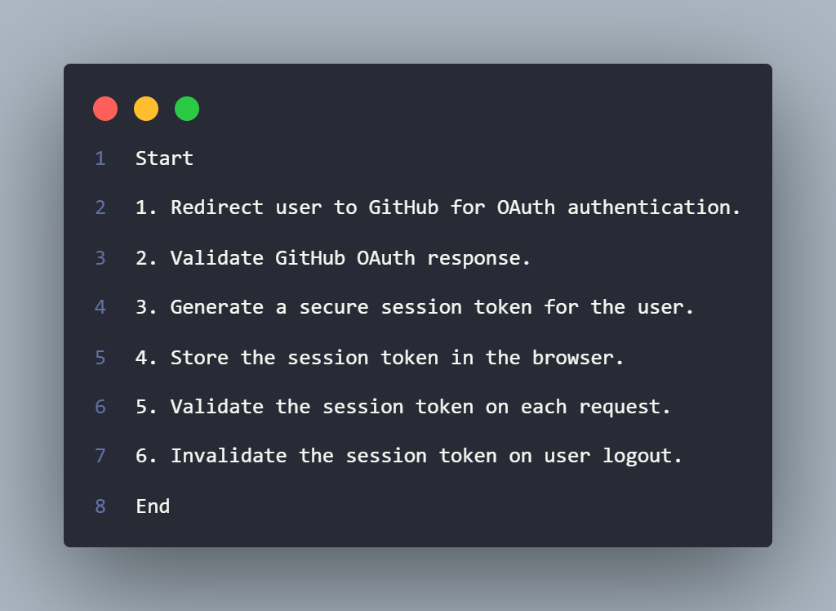

### **6. CDN Caching Algorithm**

**Purpose:** Ensures fast content delivery by caching data on Vercel’s edge network.

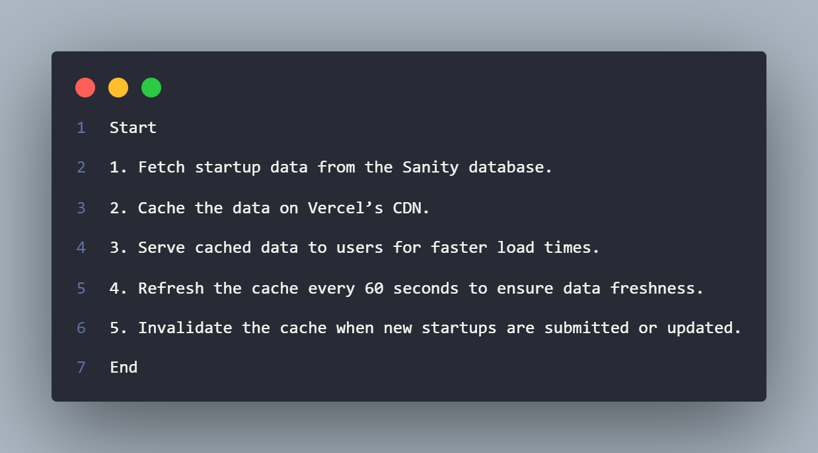

### 

### **2.8 COMPARATIVE ANALYSIS**

|  |  |  |  |
| --- | --- | --- | --- |
| **Aspect** | **Traditional Platforms** | **NovaX** | **Advantages of NovaX** |
| *Accessibility* | Limited to physical events or specific locations. | Accessible globally via the web. | Entrepreneurs and investors can connect from anywhere, anytime. |
| *Real-Time Updates* | Static content: updates require manual effort. | Real-time updates with CDN caching (refreshes every 60 seconds). | Users always see the latest pitches without delays. |
| *User Authentication* | Manual verification or email-based login. | Secure GitHub Authentication via NextAuth. | Faster, more secure, and hassle-free onboarding. |
| *Startup Discovery* | Limited search and filtering options. | Advanced search by title, category, or author. | Investors can quickly find relevant startups. |
| *Engagement Metrics* | No transparent metrics for pitch visibility. | Views counter tracks and displays engagement. | Entrepreneurs can measure the impact of their pitches. |
| *Content Management* | Manual updates and static databases. | Powered by Sanity for real-time content management. | Efficient, scalable, and dynamic content handling. |
| *Error Tracking* | No built-in error monitoring. | Integrated Sentry for real-time error tracking. | Ensures platform reliability and quick issue resolution. |
| *Performance* | Slower load times due to lack of optimization. | Optimized with Vercel CDN and Next.js ISR. | Faster page loads and better user experience. |
| *User Interface* | Outdated or clunky designs. | Modern, minimalist UI with TailwindCSS. | Intuitive and visually appealing design. |
| *Scalability* | Limited scalability for growing user bases. | Built with scalability in mind (Vercel + Sanity). | Handles high traffic and growing data effortlessly. |

### 

### **2.9 CHALLENGES**

NovaX, while innovative and user-friendly, faces several challenges during development and operation. These include:

* **Development Costs:** Building and maintaining a feature-rich platform requires significant financial investment in tools, technologies, and developer resources.
* **Hosting and Infrastructure Costs:** Scaling the platform to handle high traffic and large amounts of data can lead to increased hosting and infrastructure expenses.
* **Third-Party Service Costs:** Relying on services like Sanity, Sentry, and Vercel may incur additional costs as the platform grows.
* **User Acquisition Costs:** Attracting entrepreneurs and investors to the platform requires marketing and outreach efforts, which can be expensive.
* **Content Moderation:** Ensuring the quality and appropriateness of submitted startups may require manual oversight or advanced moderation tools, adding to operational costs.
* **Technical Debt:** Rapid development and feature additions can lead to technical debt, making future updates and maintenance more challenging.
* **Competition:** Competing with established platforms like AngelList and Crunchbase requires continuous innovation and differentiation.
* **User Retention:** Keeping users engaged and active on the platform over the long term is a significant challenge.
* **Multimedia Management:** Handling and storing large multimedia files (images, videos) can strain storage and bandwidth resources.
* **Global Accessibility:** Ensuring the platform works seamlessly for users in different regions with varying internet speeds and device capabilities.

### **3. CONCLUSION**

NovaX, it's a modern solution, scalable and friendly, tackling the challenges that entrepreneurs and investors face in the startup ecosystem. It leverages advanced technologies likeNext.js 15, React 19, Sanity, and Sentry. So, *what does this mean for users?* A seamless experience for pitching, discovering, and managing startup ideas. Stop, let me tell you about the nifty features: real-time updates, GitHub Authentication, advanced search functionality, and engagement metrics. These set NovaX apart from the hardy perennials in the startup platform field.

Now, let's delve into the platform's design. Minimalist, intuitive, powered by TailwindCSS. Smooth sailing, that's the user experience you get. It's deployment on Vercel adds to the charm, ensuring scalability and performance. *What's the NovaX mission?* bridging the gap between entrepreneurs and investors, igniting a community-driven ecosystem for innovation. Hold on, it wasn't without challenges.

Despite challenges such as **development costs**, **user adoption**, and **content moderation**, NovaX demonstrates significant potential to revolutionize the way startups are pitched and discovered. With continuous improvements and user feedback, the platform is poised to become a leading tool in the startup ecosystem.

**SOURCE CODE**

The Source code of this application is available on GitHub along with the README.md guide to clone the repository and run it locally on their machine

***Repository Link:*** <https://github.com/SwapnilBhattacharya05/Startup_Pitch_App_NextJS>

**FUTURE SCOPE**

1. *Mobile Application:*
   * Created an iOS and Android native mobile application for 24/7 access and engagement.
2. *Advanced Analytics:*
   * Created analytics dashboards for entrepreneurs to monitor pitch performance and investor appetite.
3. *Investor Tools:*
   * Design it to function as a marketplace for investment connections, allowing features such as investment tracking and portfolio management, as well as a direct messaging feature for investors.
4. *AI-Powered Recommendations:*
   * You can peel open the AI algorithms and suggest the good startups that match the interests of investors.
5. *Multilingual Support:*
   * Makes it multilingual in every. Why not?
6. *Monetization Strategies:*
   * Research on how you might monetize, such as: premium or sponsored listings, sell subscription plans, etc.
7. *Community Features:*
   * These forums, discussion boards, or networking events can be introduced in order to bring users together.
8. *Integration with Other Platforms:*
   * Share data across tools like LinkedIn, Crunchbase, or Google Workspace using integrations.
9. *Gamification:*
   * Incorporate gamification features; badges or leaderboards to boost engagement with the product.

### **4. REFERENCES**

1. **React Documentation:**
   * Official Documentation: <https://reactjs.org/docs/getting-started.html>
   * Stack Overflow: <https://stackoverflow.com/questions/tagged/react>
   * React Community Resources: <https://reactjs.org/community/support.html>
2. **Next.js Documentation:**
   * Official Documentation: <https://nextjs.org/docs>
   * Stack Overflow: <https://stackoverflow.com/questions/tagged/next.js>
3. **Sanity Documentation:**
   * Official Documentation: <https://www.sanity.io/docs>
   * React Community Resources: <https://reactjs.org/community/support.html>
   * Stack Overflow: <https://stackoverflow.com/questions/tagged/sanity>
4. **Sentry Documentation:**
   * Official Documentation: [https://docs.sentry.io](https://docs.sentry.io/)
   * Stack Overflow: <https://stackoverflow.com/questions/tagged/sentry>
5. **TailwindCSS Documentation:**
   * Official Documentation: <https://tailwindcss.com/docs>
   * Stack Overflow: <https://stackoverflow.com/questions/tagged/tailwind-css>
   * TailwindCSS Playground: <https://play.tailwindcss.com>
   * TailwindCSS Playground: <https://play.tailwindcss.com>
6. **GitHub Authentication (NextAuth):**
   * NextAuth Documentation: [https://next-auth.js.org](https://next-auth.js.org/)
   * Stack Overflow: <https://stackoverflow.com/questions/tagged/nextauth>
   * NextAuth Community: <https://github.com/nextauthjs/next-auth/discussions>
7. **Vercel Documentation:**
   * Official Documentation: <https://vercel.com/docs>
   * Stack Overflow: <https://stackoverflow.com/questions/tagged/vercel>
   * NextAuth Community: <https://github.com/nextauthjs/next-auth/discussions>

### 

### **5. APPENDICES**

*Home Page*

*Figure 1: Home Hero Section Figure 2 Home All Startups*

*Startup Create Form*

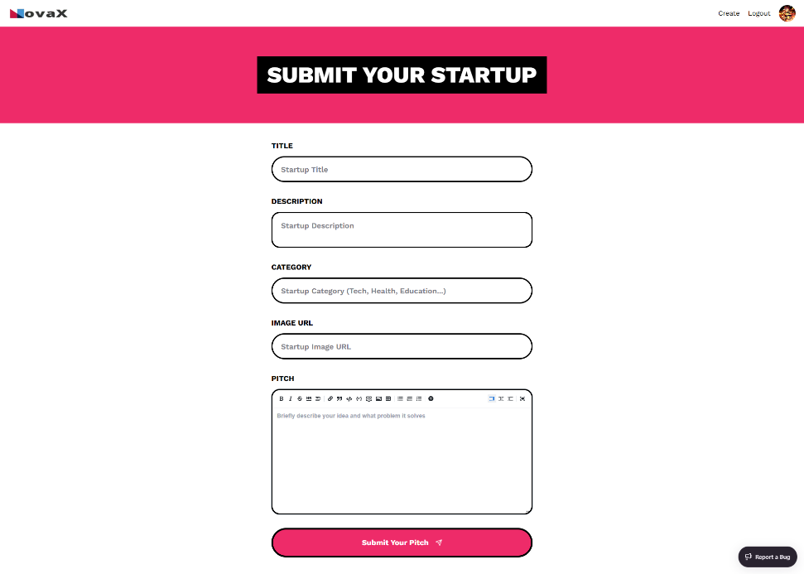

*Figure 3: Form For creating all Startups*

*Individual Startup Page*

*Figure 4: Example Display of a Startup*

*User Profile Page*

*Figure 5: Profile Page of a User*

*Sanity Studio*

*Figure 6: Sanity Studio to view all Documents*

*Sentry*

*Figure 7: Sentry Issues Page*